**Android Styles and Themes**

**Aim:** Define a custom style for controls in [LinearLayout](https://www.tutlane.com/tutorial/android/android-linearlayout-with-examples) to apply different styles for controls in the android application.

**PROGRAM**

// open **styles.xml** file from **\res\values** folder and write the code like as shown below.

## styles.xml

## <resources>

## <!-- Base application theme. -->     <style name="AppTheme" parent="Theme.AppCompat.Light.DarkActionBar">         <!-- Customize your theme here. -->         <item name="colorPrimary">@color/colorPrimary</item>         <item name="colorPrimaryDark">@color/colorPrimaryDark</item>         <item name="colorAccent">@color/colorAccent</item>     </style>     <style name="TextviewStyle" parent="@android:style/Widget.TextView">         <item name="android:layout_width">wrap_content</item>         <item name="android:layout_height">wrap_content</item>         <item name="android:layout_marginLeft">100dp</item>         <item name="android:layout_marginTop">10dp</item>         <item name="android:textColor">#86AD33</item>         <item name="android:textStyle">bold</item>         <item name="android:textSize">20dp</item>     </style>     <style name="ButtonStyle" parent="@android:style/Widget.Button">         <item name="android:layout_width">200dp</item>         <item name="android:layout_height">wrap_content</item>         <item name="android:layout_marginLeft">100dp</item>         <item name="android:layout_marginTop">10dp</item>         <item name="android:textColor">#FFFFFF</item>         <item name="android:background">#F1511B</item>         <item name="android:textStyle">bold</item>         <item name="android:textSize">15dp</item>     </style>     <string name="wlcmsg">welcome to Tutlane</string> </resources>

If you observe above code, we defined a two styles (**TextViewStyle**, **ButtonStyle**) and we can apply these styles for required controls in android application.

Now open an **activity_main.xml** file from **\res\layout** path and write the code like as shown below

## activity_main.xml

<?xml version="1.0" encoding="utf-8"?>  
<LinearLayout xmlns:android="http://schemas.android.com/apk/res/android"  
    android:layout_width="match_parent"  
    android:layout_height="match_parent"  
    android:orientation="vertical" >  
    <TextView  
        android:id="@+id/TextView1"  
        android:layout_width="wrap_content"  
        android:layout_height="wrap_content"  
        android:layout_marginLeft="100dp"  
        android:layout_marginTop="200dp"  
        android:textColor="#00ADEF"  
        android:textSize="15dp"  
        android:text="@string/wlcmsg"/>  
    <TextView  
        android:id="@+id/TextView2"  
        style="@style/TextviewStyle"  
        android:text="Welcome to Tutlane"/>  
    <Button  
        android:id="@+id/btnShow"  
        android:text="Click on Button"  
        style="@style/ButtonStyle" />  
</LinearLayout>

## Output of Android Styles and Themes Example

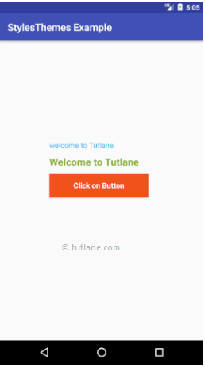

This is how we can use the styles and themes in our applications to change the appearance of [UI controls](https://www.tutlane.com/tutorial/android/android-ui-controls-textview-edittext-radio-button-checkbox) by reducing code duplication.